This level intends to make the user think logically and start counting blocks moved forward. Sometimes, perhaps, the best way to secure correct execution is to count every step yourself. The user should now be having a few ideas about how programming is performed. We are trying to extend this knowledge to further cases.

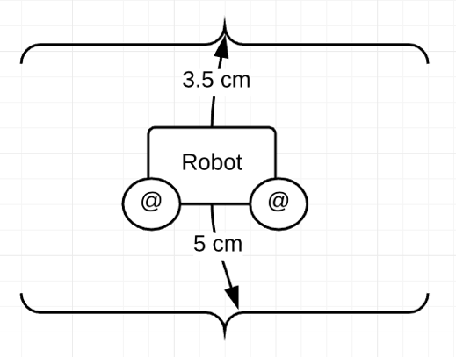Our game only simulates mars explorer. But what if real NASA commanded their robot to move forward? They should be aware of the exact distance it will move. That is to say, although computing may be very theoretical and abstract in some ways, a huge part of it is concerned about real world measurements.

As a part of curriculum, University College London offers programming on robots to the students. *See Figure 1 for further reference.* This involves measuring distances, time, angle, accuracy and many more other practical factors. In a certain manner, our game copies these tasks and replicates in an easy gameplay – with less factors to consider, for now.

Figure 1: Real distance counting